Harmonised audit of operations report template

July 2023, version 1.1

Copyright: You are permitted to print, download and use this material for your personal use, and for public use. The material should always be presented with the original source acknowledged, including any relevant third-party owners acknowledged in the material. None of this material may be used for commercial purposes.

Disclaimer: Cooperation can be complex, and while Interact’s job is to make it easier, Interact cannot offer assurances on the accuracy of our pan-European information in any specific context. Furthermore, understanding and knowledge evolve throughout the programming period. If you spot something out of date or inconsistent, please contact us at przemyslaw.kniaziuk@interact-eu.net or iuliia.kauk@interact-eu.net.

Publisher Interact Programme
Date 07.2023

Harmonised audit of operations report template

(Final version 1.1 – July 2023)

This is a report template for the audit of operations developed by Interact in cooperation with a dedicated group of AAs and MAs.

The goal is to assist Interreg audit authorities in developing their templates for the 2021 – 2027 programming period. It is not a compulsory template and it may be used as is or in parts, or only for inspiration by AAs.

The main objectives of this template are:

- to reflect some issues linked to the work done by auditors ;
- to provide a flexible framework for the audit of operations reports that can be used and modified by AAs, as needed;
- to share information on different possible scope options, approaches, and practices.

Guide for monitoring systems:

- the document can be built into the system to allow most information to be automatically generated from existing information located elsewhere.

General guidelines:

- watch out for the comments in the document, as these include important additional information on how to fill in the template, what guidance exists, what optional procedures/practices can be applied, etc.

In version 1.1 of the present document references to methodological notes were revised and minor typos were corrected.

FINAL / DRAFT AUDIT REPORT

Audit type: | Audit of operations in compliance with Article 77(1) of Regulation (EU) No. 2021/1060 and Article 48(2) of Regulation (EU) No. 2021/1059
Audited (lead) beneficiary: | <Name of audited beneficiary>
Audited operation: | Text
Audited programme: | Text
Audited accounting year: | Text
Date of the on-the-spot audit: | Date / N/A
Place and date of issue of draft report: | Text
Place and date of issue of final report:

__________________________________________
Name and signature of responsible auditor / legal representative of the auditor

Table of contents

1. EXECUTIVE SUMMARY …..5
2. INTRODUCTION 7
3. GENERAL INFORMATION RELATED TO THE AUDIT 8
3.1. Auditing organisation 8
3.2. Programme bodies responsible for implementation and control 8
3.3. Audited operation 8
3.4. Audited beneficiary 8
3.5. Audited sample 9
4. SCOPE AND OBJECTIVES OF THE AUDIT WORK DONE 10
5. DESCRIPTION OF FINDINGS 12
6. CONCLUSION 14
7. CONTRADICTORY PROCEDURE 15
Annex 1: List of abbreviations 16
Annex 2: Financial information related to the audit 17
Annex 3: Parameters of the sub-sampling 19
Annex 4: Comments received during the contradictory procedure and responses 20

EXECUTIVE SUMMARY

The result of the audit regarding the expenditure declared by <Name of audited beneficiary> as (Lead) beneficiary of <Project ID> in the audited accounting year:

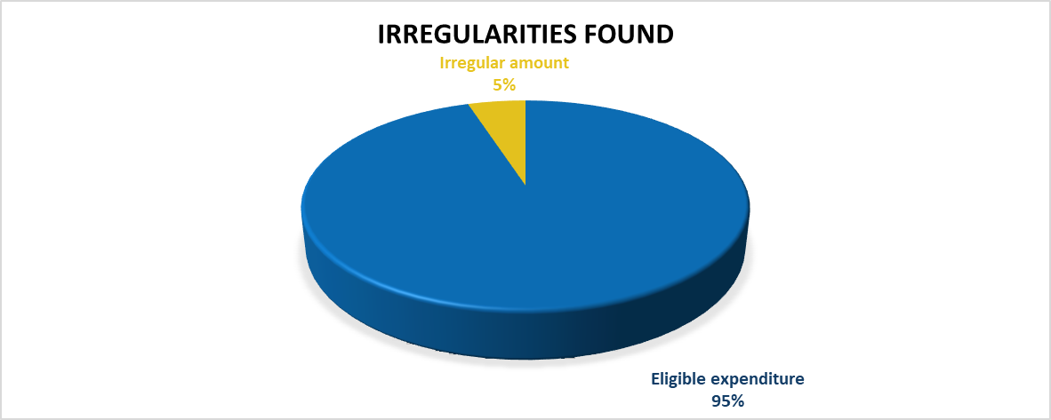

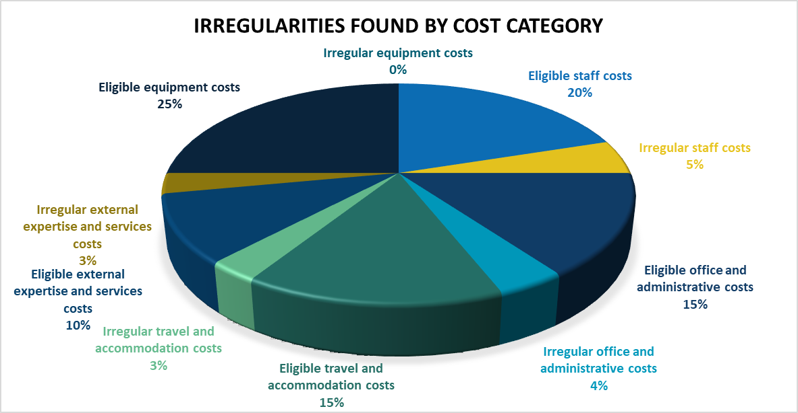

Findings related to the audited sample: | No findings  OR  Finding No. 1  Finding No. 2  ....
Findings not related to the audited sample: | N/A  OR  Finding No. 2
Other comments: | N/A  OR  Go to Conclusion

INTRODUCTION

XXX, as Audit Authority responsible for the audits of operations within the Programme /Audit body and Member of the Group of Auditors responsible for the audits of operations on its territory within the Programme has performed the audit of XXX as beneficiary of project no XXX in compliance with Article 77(1) of Regulation (EU) No. 2021/1060 and Article 48(2) of Regulation (EU) No. 2021/1059.
OR
Based on the service contract signed with XXX, acting as the Audit Authority/Managing Authority/other for the Programme, XXX has performed the audit of XXX as beneficiary of project no XXX within the Programme, in compliance with Article 77(1) of Regulation (EU) No. 2021/1060 and Article 48(2) of Regulation (EU) No. 2021/1059.

The beneficiary has been selected for audit by the European Commission in the framework of the common Interreg sample for the accounting year XX – XX+1.
OR
The beneficiary has been selected for audit by the audit authority based on the expenditure declared to the European Commission in the accounting year XX – XX+1 based on XXX sampling method.

The audit was carried out in compliance with internationally accepted audit standards and in accordance with the audit strategy for the Programme.

A desk-based audit was performed based on documents available in the monitoring system used by the audited Programme, and data requested from the audited beneficiary.
OR
The audit was performed on-the-spot and based on documents available in the monitoring system used by the audited Programme, as well as data requested from the audited beneficiary, as necessary.

GENERAL INFORMATION RELATED TO THE AUDIT

Auditing organisation

Responsible Audit Authority: | Text
Organisation carrying out the audit: | Text

Programme bodies responsible for implementation and control

Managing Authority responsible for the programme: | Text

Audited operation

ID and name of the audited operation: | Text
Priority: | Text
Description of the operation: | <Brief description of the operation’s activities and objectives>
Approved EU funding for the operation: | Text
Implementation period of the operation according to the subsidy contract / grant agreement: | Text
Operation is still being implemented at the time of the audit: | Yes / No

Audited beneficiary

Name of the auditee: | <Name of beneficiary>
Status of auditee within the operation: | Lead beneficiary / beneficiary
Legal status: | Private/Public beneficiary
Registered in: | <MS or Country code>
Approved EU funding for the auditee: | Text
Fund: | The Interreg Funds
Co-financing rate:
Is State aid involved:
Has the audited (lead) beneficiary been audited before in the context of this operation (AA/EC/ECA):

Audited sample

Payment claim(s) audited (nr):
Total amount of expenditure in the audit sample: | Text
Total amount of expenditure audited: | <All expenditure in the sample has been audited / XXX EUR. Parameters of the sub-sampling are included in Annex XX>
Does the sample include expenditure linked to public procurement: | Text
Has any of the expenditure in the audit sample been verified by a controller before validation (all or part or none of it): | Text

SCOPE AND OBJECTIVES OF THE AUDIT WORK DONE

The scope of the work corresponded to the expenditure declared to the Commission in the accounting year XX – XX+1, in respect of the audited beneficiary within the operation XXX. The audit sample was based on the sampling of the EC / AA, carried out in accordance with Art. 49 of the Interreg Regulation / Art. 79 CPR.

The general objective of the audit mission was to verify based on supporting documents:
- the legality and regularity of expenditure declared to the EC,
- the encoding in the accounting system,
- and the audit trail.

The audit covered the verification of the following specific aspects:
- eligibility of the operation, the beneficiary and regularity of the selection procedure and contracting in respect of the audited beneficiary, including compliance with horizontal principles and State aid rules;
- reality of the project part and regular implementation in accordance with the approval decision and fulfilment of conditions applicable at the time of the audit concerning its functionality, use, and objectives to be attained, in line with the principle of sound financial management;
- compliance of the audited partner with transparency, communication and visibility requirements;
- eligibility of the audited expenditure both for grants taking the form set out in point (a) of Article 53(1), including respect of public procurement rules, and for grants taking the forms set out in points (b), (c) and (d) of Article 53(1), including the method of establishing and the implementation of the unit costs, lump sums and flat rates, as necessary;
- reliability of data in relation to output and result indicators, also enabling reconciliation with corresponding targets and reported milestones;
- audited expenditure’s compliance with applicable EU, programme and national rules;
- existence of a separate accounting record or code for project expenditures, and an adequate audit trail that is consistent with the available supporting documentation;
- correspondence of the expenditure declared to the Commission with the accounting records in the managing authority's electronic system, and the documentation related to financial corrections and deductions from the expenditure declared to the Commission, ensuring compliance with Article 98(6) CPR;
- absence of double funding of expenditure;
- absence of fraud and conflict of interest;
- where the audited expenditure, or at least part of it, has been subject to administrative or on-the-spot management verification, quality and documentation of the work of the controller;
- if relevant, examination of whether errors, deficiencies and irregularities revealed by the audit are of systemic nature;
- rules, processes and procedures that constitute an excess administrative burden and cost, or that can be simplified without undermining the overall assurance and effectiveness of the management and control system, and identification of good practices revealed during the audit, if any.

DESCRIPTION OF FINDINGS

Finding No. 1.
Classification of finding (random, systemic, anomalous):
Type of error (based on the typology of findings in Annex 4 of draft Methodological Note on the Annual control report, audit opinion, and treatment of errors)
In case of a systemic finding, categorization based on impact (major/medium/minor):
In case of a systemic finding, categorization of finding based on assessment criteria of the management and control system (MCS):
In case of finding with financial impact, ref. no. of payment claim(s) affected:
In case of finding with financial impact, ref. no. of invoice(s) / item(s) affected:
In case of finding with financial impact, category(/ies) of expenditure affected (Art. 39-44 of the Interreg Regulation):
Legal basis for the finding:
Description of the finding:

Financial impact of irregularity, if relevant:

Other related known or potential financial impact found by the audit, if relevant (outside the current sample):

Recommendation / necessary measures:

Deadline for implementation of recommendation:
Addressee of the recommendation:

Finding No. 2.
Titles | Alternate white and grey to show distinction in cells
Titles | N.B. Update coming later in 2023 to have a better approach to the white lines within such tables, not always clear enough.
Titles | Text
Titles | Text

<repeat table for other findings >

CONCLUSION

Based on the audit work done, no findings have been detected regarding the audited expenditure and processes.
OR
Based on the audit work done, no findings with financial impact have been made regarding the declared expenditure.
However, the audit makes the following recommendation(s):……
OR
Based on the audit work done, irregular expenditure in the amount of XXX EUR (EU contribution: XXX EUR) has been detected (see Finding no. XX). The irregular amount shall be deducted from the next accounts submitted to the EC.
Furthermore, the audit makes the following recommendation(s):….
The recommendation(s) of the audit shall be implemented by:....
Based on the work carried out in the framework of this audit mission, the audit found no issues that need to be reported to OLAF.
OR
Based on the work carried out in the framework of this audit mission, a report to OLAF is required in connection with finding no. ….
While performing the audit tasks related to the audited sample, the audit has also identified a good practice: ….

CONTRADICTORY PROCEDURE

For draft report:
Based on XXX comments on the draft report can be provided within 10 working days.
Failure to provide comments within the deadline shall be deemed as acceptance of the draft report.

For final report:
Prior to the issuing of the final report the draft audit report was submitted for contradictory procedure to all auditees.
No comments have been received.
OR
The comments received have been given due consideration when drawing up the final report.
The comments and the responses to the comments are included in Annex 4.

Annex 1: List of abbreviations

Abbreviation

Annex 2: Financial information related to the audit

  - Summary of financial information related to the audit

 | Expenditure – EU contribution | Expenditure – National contribution | Expenditure – Public contribution | Expenditure – Private contribution | Expenditure - Total
Amount in the sample related to the beneficiary
Amount audited related to the beneficiary
Irregular amount found by the audit
Irregular amount determined by the audit
Amount found eligible by the audit

  - Itemised data on irregularities found
Item | Budget line | Expenditure – EU contribution | Expenditure – National contribution | Expenditure – Public contribution | Expenditure – Private contribution | Expenditure - Total
FINDING NO. 1
Item 1
Item 1
…..
FINDING NO. 2.
Item 1
…..

  - Itemised data on known errors found

 | Budget line | Expenditure – EU contribution | Expenditure – National contribution | Expenditure – Public contribution | Expenditure – Private contribution | Expenditure - Total
FINDING NO. 2
Item 1
Item 2
…..

Annex 3: Parameters of the sub-sampling

Annex 4: Comments received during the contradictory procedure and responses

